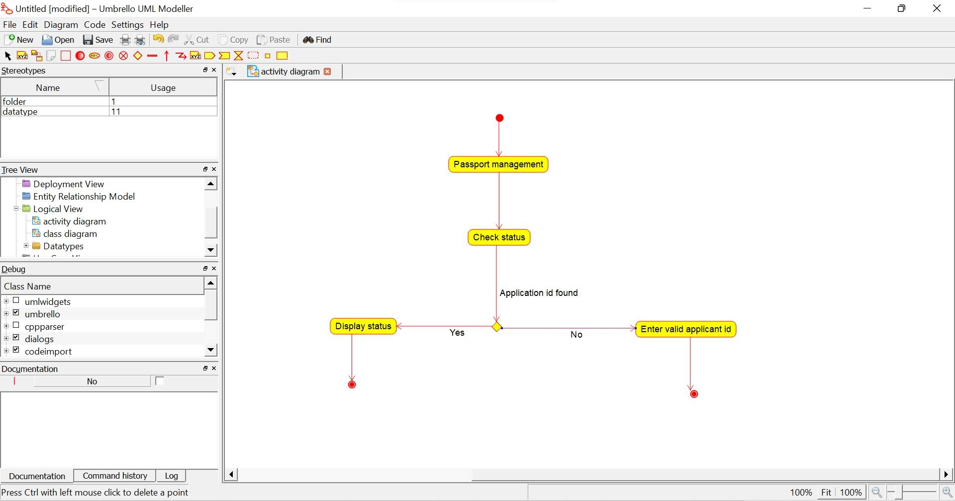1.**PASSPORT_ACTIVITY DIAGRAM:**

2.**PaASSPORT_CLASS DIAGRAM:**

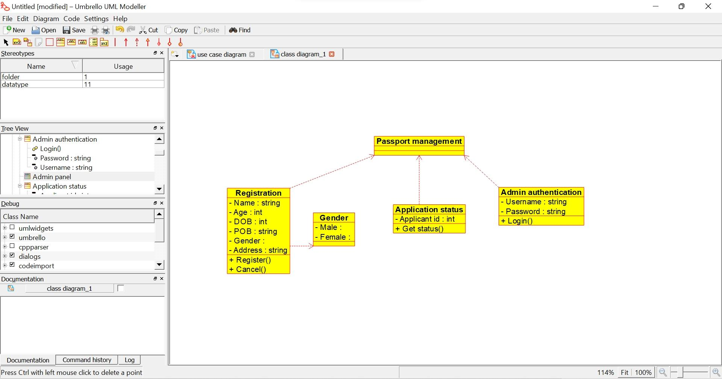

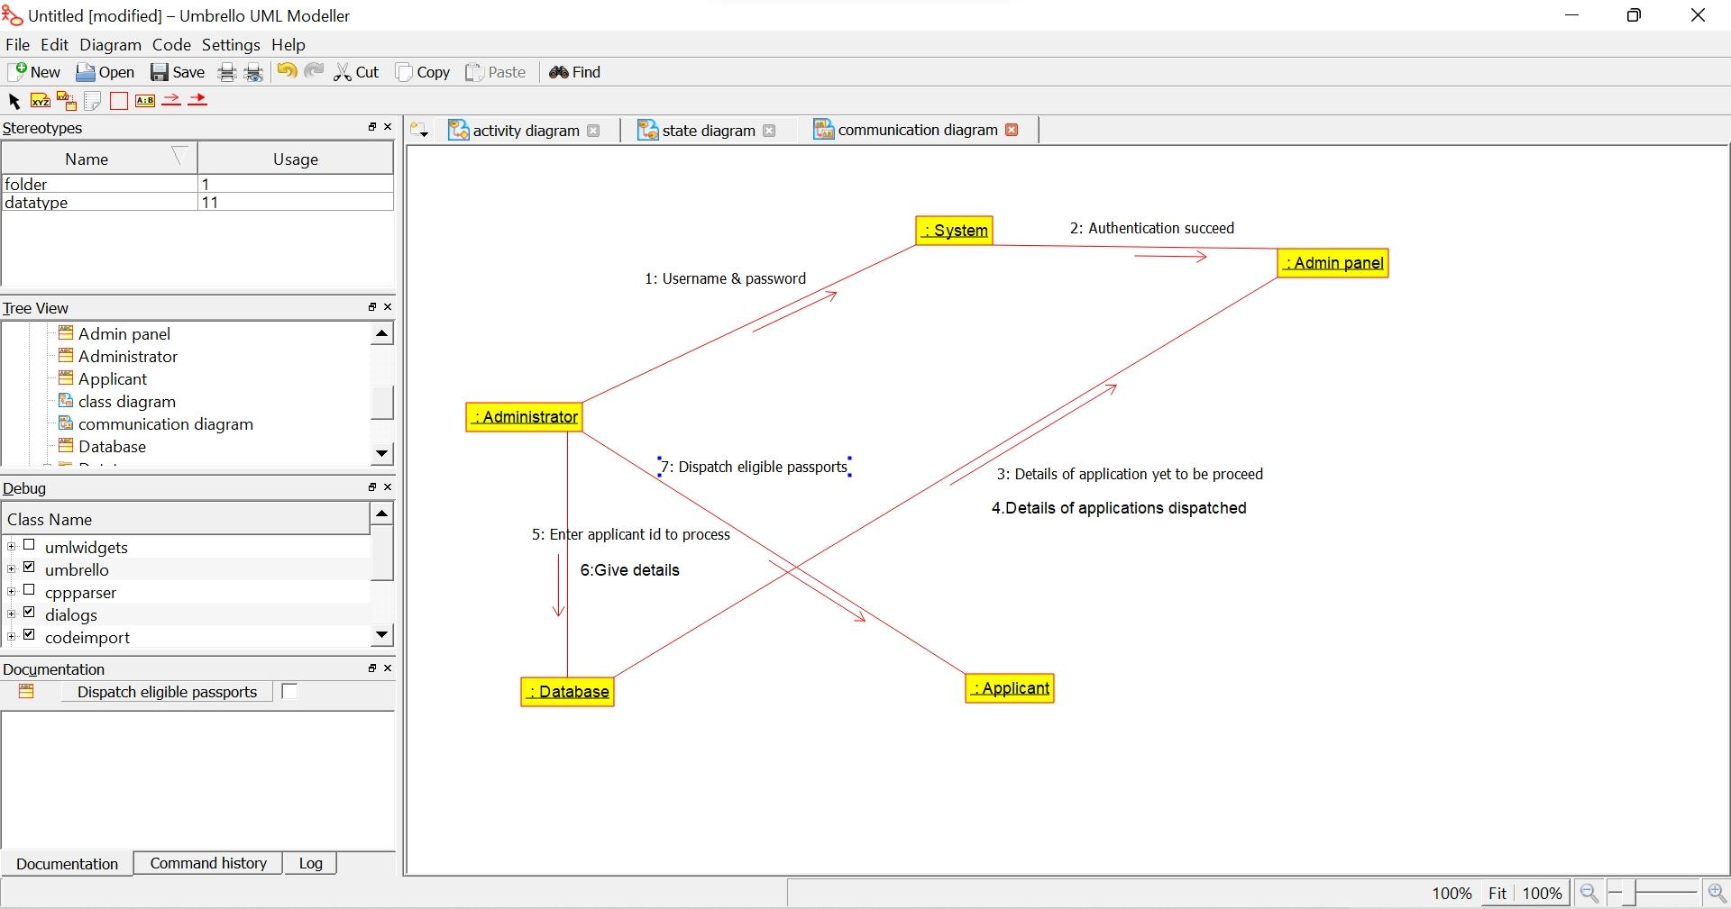**3.PASSPORT _COLLABORATION DIAGRAM:**

**4.PASSPORT_COMPONENT DIAGRAM:**

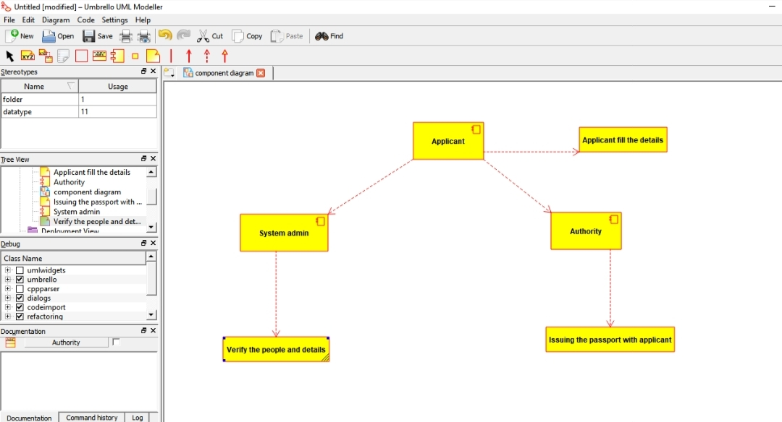

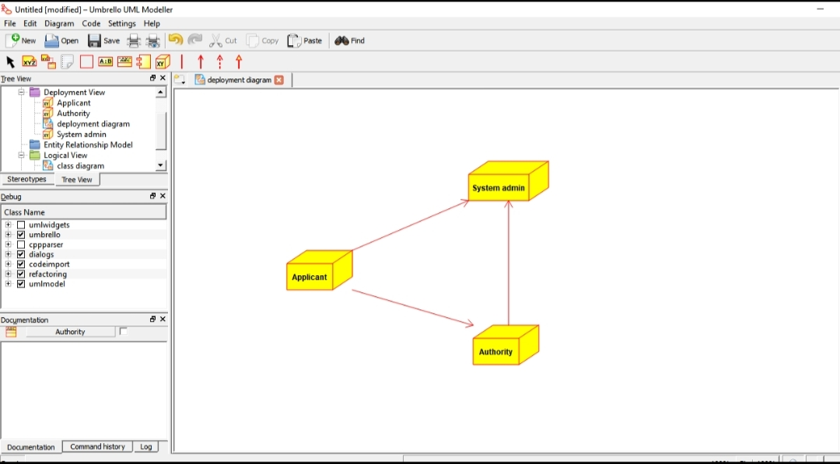**5.PASSPORT_DEPLOYMENT DIAGRAM:**

**6.PASSPORT_SEQUENCE DIAGRAM:**

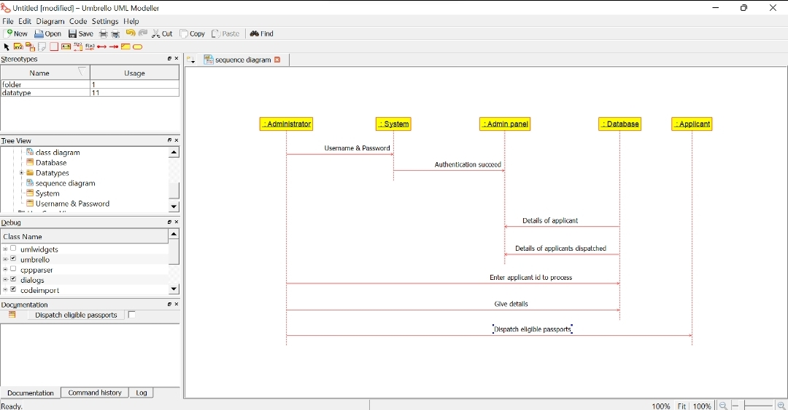

**7.PASSPORT_STATE DIAGRAM:**

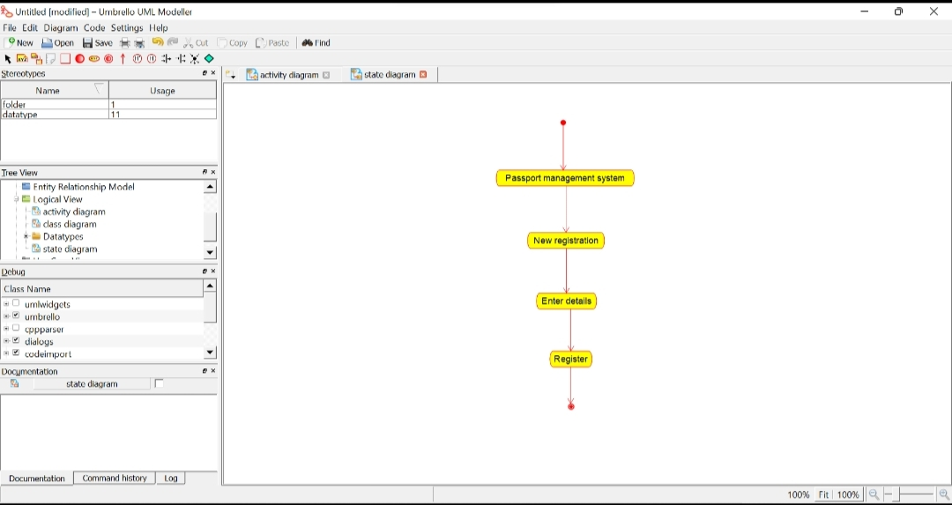

**8.PASSPORT_USECASE DIAGRAM:**

